

Puffell.com

Case Study

Our Results

There is growing evidence that the platform is proving to be:

* Popular: since the Beta test launch and with no major advertising or promotion, more than 4,600 users are registered on Puffell.com
* Equitable: the majority (68%) of users are aged between 21 and 60. The platform spans the socio-economic divide, with one analysis in the Wirral area demonstrating proportional use from across all key demographics
* Useful: of those users tracking a lifestyle behaviour, 54% track two or more
* Important: 8% of all users have a long term condition. Of those, 54% said improving their self care was a high priority to them, demonstrating its value
* Effective: of those tracking the amount of cigarettes they smoke, we have reductions in the mean number of cigarettes smoking from 10.2 per day to 2.8 per day over a mean time of 158 days. We have reductions in the mean number of units consumed from those who are tracking the number of units they drink from 7.9 per day to 4.3 per day over a mean time of 127 days. From those tracking their weight, we have seen reductions in the mean weight from 80.8kgs to 3.1kgs per day over a mean time of 168 days
* Sustainable: Puffell demonstrates an opportunity for stakeholders to activate a substantial increase in local populations ‘actively’ managing their lifestyle and health conditions.

Puffell has been nominated as a national innovation case study by NHS England and is being incorporated into digital engagement strategy for Public Health England.

ICE Creates is working with 12 health and social care partners and Public Health England to develop an online platform that supports citizens and communities to make better happen; a behaviour change tool created for the next generation of health and wellbeing services.

Our Solution

We have combined our strengths in behavioural economics, marketing communications and digital solutions to create a powerful platform to support individuals to manage their lifestyles more effectively online.

Functionality includes:

* An initial lifestyle assessment – aimed at understanding user lifestyles and their propensity to change
* Groups functionality – supporting services, communities and small groups of people to come together for a common interest or goal
* Diary – a place where tracking and goal setting is managed, as well as a space for recording and reminding users about appointments, important dates etc.
* Notifications – keeping users tracking and moving forward on their journey of sustainable change
* Lifestyle decks – smoking, alcohol, healthy weight, physical activity
* Long term conditions tools and trackers to support diabetes, asthma and viral wheeze, dementia, mental health, COPD and CAMHS, as well as workplace wellness and NHS Health Checks
* Exchange – the social chat element of Puffell where users can connect and chat with their friends
* What’s around me – this is the service directory and enables users to find and connect with local services.

The site is mobile optimized and a smartphone app version is in development. Pathways for life and Puffell are perfect as an integration focal point: person-centred and data driven.

The brief

Lorem ipsum factor doreem it sorifinitti coreem et factor del tasimo de facto et lerotillini soriem. Lorem ipsum factor

Lorem ipsum factor doreem it sorifinitti coreem et factor del tasimo de facto et lerotillini soriem. Lorem ipsum factor

Lorem ipsum factor doreem it sorifinitti coreem et factor del tasimo de facto et lerotillini soriem. Lorem ipsum factor

Lorem ipsum factor doreem it sorifinitti coreem et factor del tasimo de facto et lerotillini soriem. Lorem ipsum factor

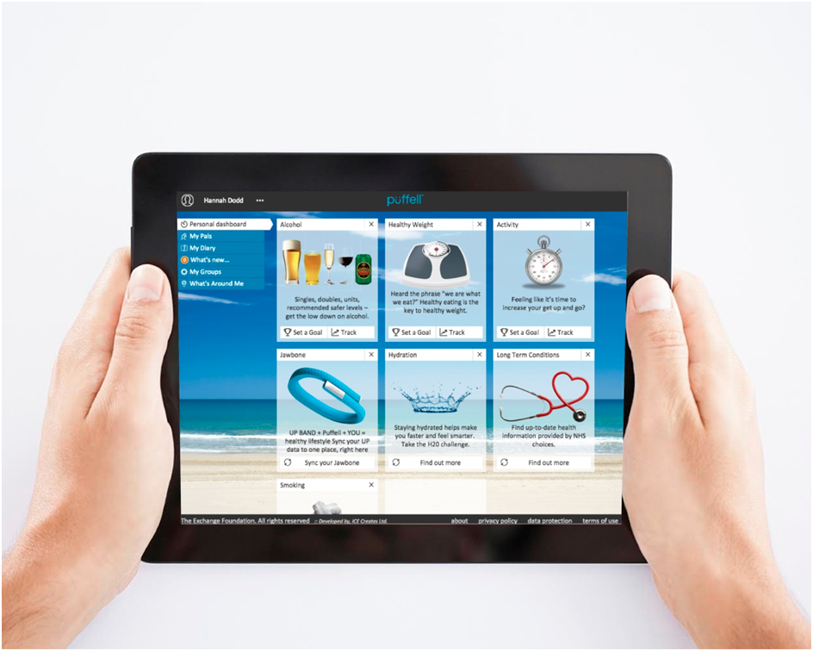



*For more information please contact:*

*Richard Forshaw*[*richard.forshaw@icecreates.com*](mailto:richard.forshaw@icecreates.com) *0845 519 3423*

Lorem ipsum factor doreem it sorifinitti coreem et factor del tasimo de facto et lerotillini soriem. Lorem ipsum factor doreem it sorifinitti coreem et factor del tasimo de facto et lerotillini soriem. Lorem ipsum factor doreem it sorifinitti coreem et factor del tasimo de facto et lerotillini soriem. Lorem ipsum factor doreem it sorifinitti coreem et factor del tasimo de facto et lerotillini soriem.

Lorem ipsum factor doreem it sorifinitti coreem et factor del tasimo de facto et lerotillini soriem. Lorem ipsum factor doreem it sorifinitti coreem et factor del tasimo de facto et lerotillini soriem.

make

better

happen